7. Develop a system using UML for implementing Credit Card Processing System. In this system, the

cardholder can purchase items and pays the bill with the aid of a credit card. The cashier should

accept the card and proceed with the transaction using the central system. The bill is to be verified

and the items are delivered to the cardholder based on it.

USE CASE DIAGRAM

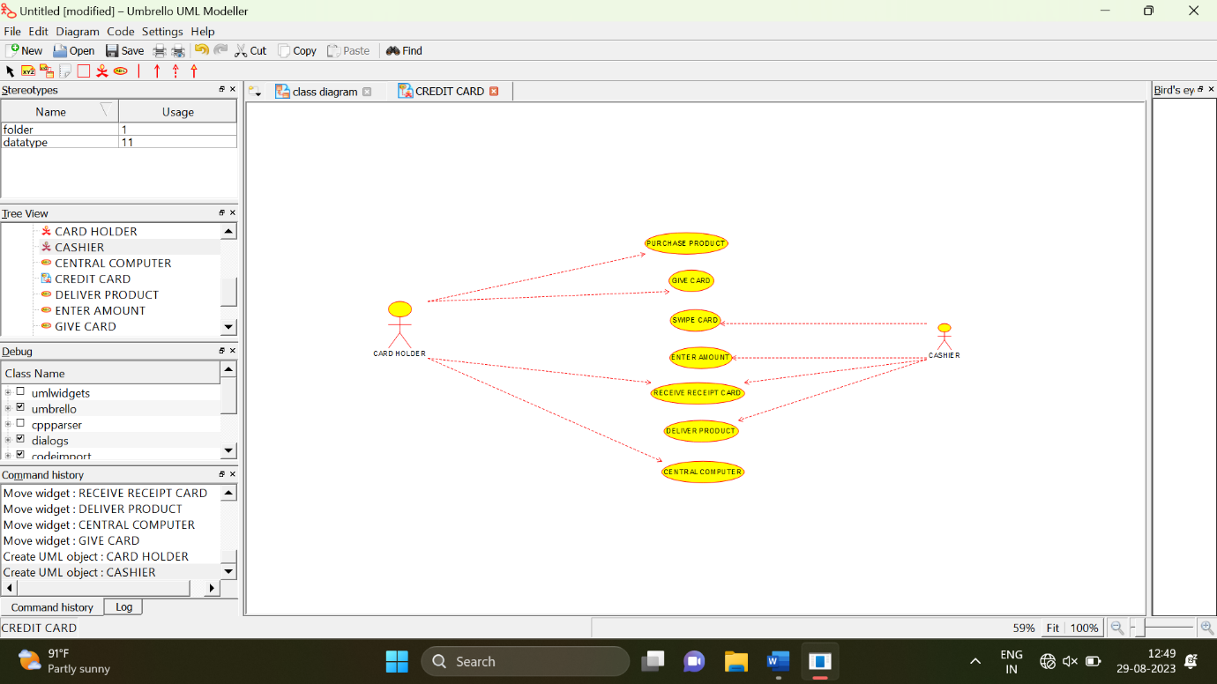

ACTIVITY DIAGRAM

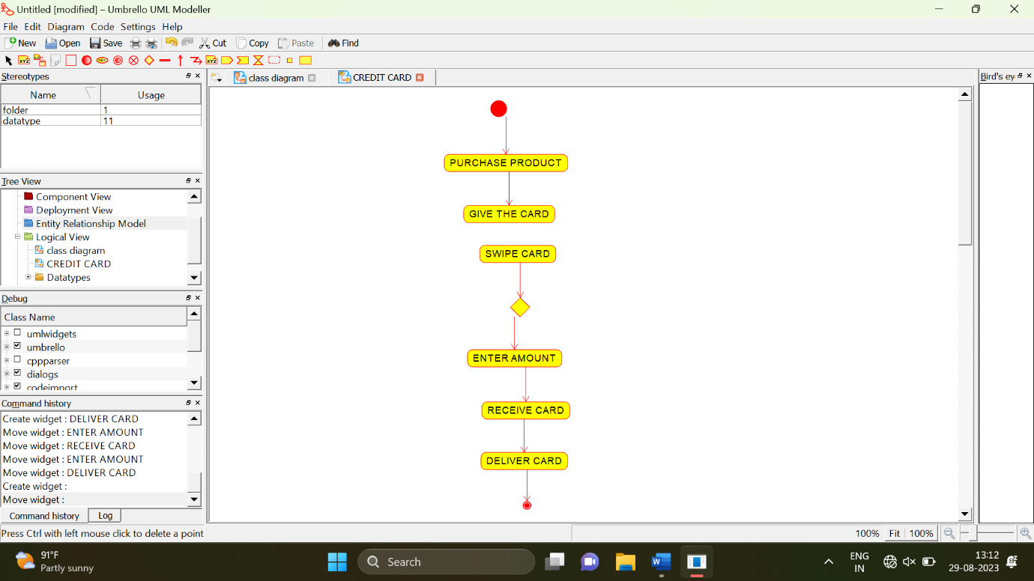

SEQUENCE DIAGRAM

